Task No 01: Print Fibonacci series ( 0,1,1,2,3,5,8…) by using for and while loop.

Input:

using System;

namespace Abdullah_Sadiq_CP_Home_Tasks

{

class Program

{

static void Main(string[] args)

{

Console.WriteLine("\t-Fibonacci series-");

Console.Write("\n n = ");

int n = int.Parse(Console.ReadLine());

int a = 0;

int b = 1;

int c = 0;

Console.Write("The Series is 0,1,");

while (n > 0)

{

c = a + b;

Console.Write(c + ",");

a = b;

b = c;

n--;

}

}

}

}

Output:

Task No 02: Repeatedly print the value of the variable x Value, decreasing it by 0.5 each time, as long as x Value remains positive. (while loop)

Input:

static void Main(string[] args)

{

double i;

Console.Write("Enter the Value of x: ");

i = Convert.ToDouble(Console.ReadLine());

while (i >0)

{

Console.WriteLine("{0,-5:0.0}- 0.5 = {1,-5:0.0}", i, i -= 0.5);

}

}

Output:

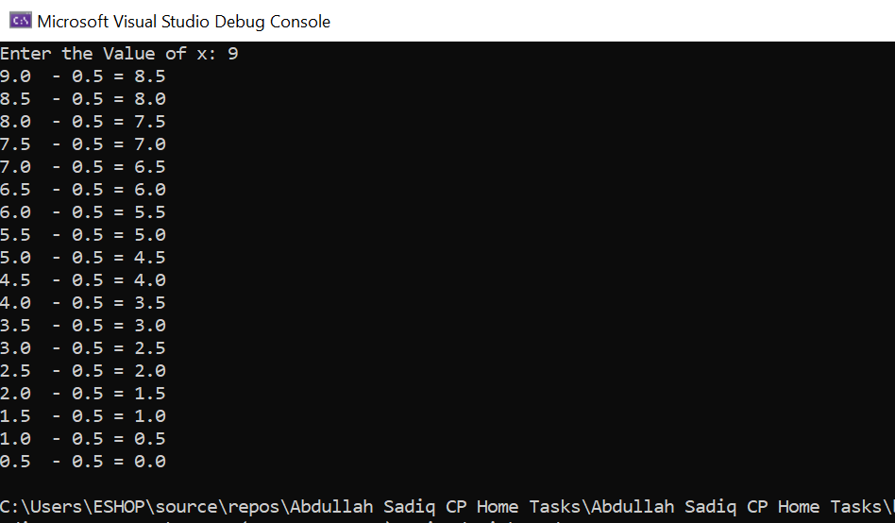

Task No 03: Print the square roots of the first 25 odd positive integers.

Input:

using System;

namespace Abdullah_Sadiq_CP_Home_Tasks

{

class Program

{

static void Main(string[] args)

{

int n = 1;

Console.WriteLine("\t-The square roots of the first 25 odd positive integers-");

while (n < 51)

{

double root = Math.Sqrt(n);

Console.WriteLine("The Square Root of {0,-2:0} is: {1,-5:0.00}", n, root);

n += 2;

}

}

}

}

Output:

